Greg Byford – “What I do in the lab blurb”

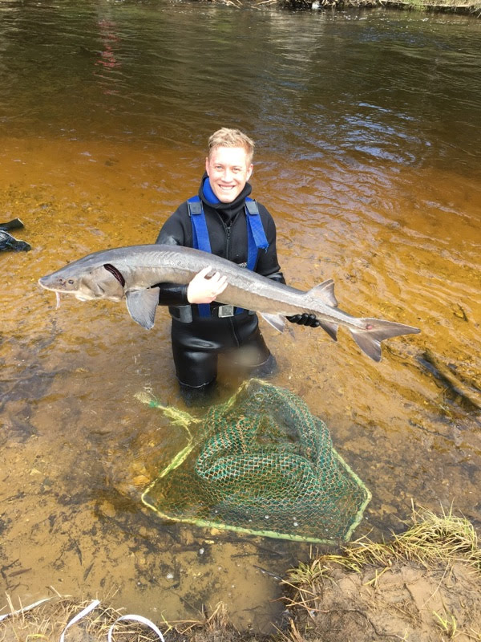

B.S. Fisheries and Wildlife 2014
M.S. Fisheries and Wildlife 2016

I am the research technician for the Michigan-Huron Predator Diet Study, whose main responsibilities are managing the processing of fish stomachs, our large Microsoft access database, and isotope preparation for further analysis. In my role, I train and manage undergraduate research assistants to process fish stomachs, through teaching identification of prey items. When I get free time, I also assist the Red Swamp Crayfish project. Want to know more about Greg? Please check out his personal website here.

Link: https://gregbyford.weebly.com/

